**AIM:**

To develop an android application to implement multimedia components

**Software/IDE Tools:**

Android Development Kit / Android Studio

**Application User interface design:**

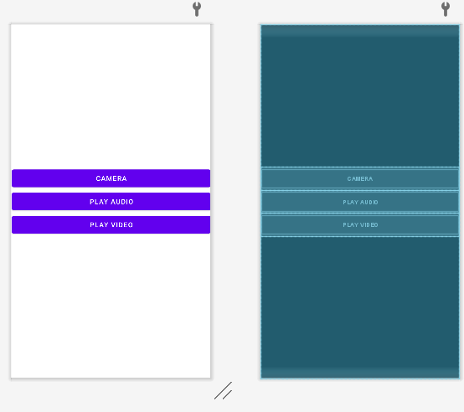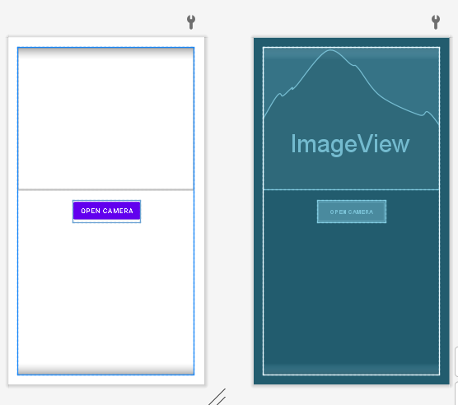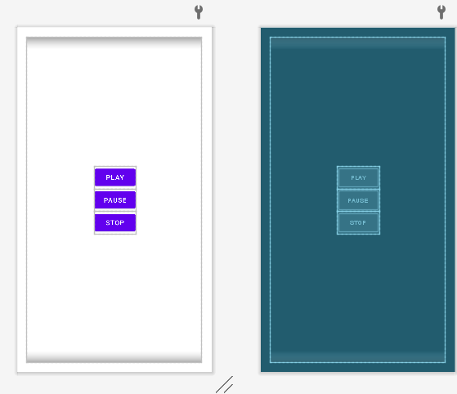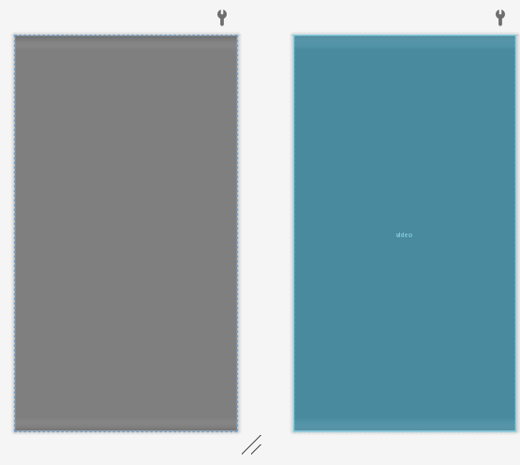

**Application Programming Interface design:**

|  |  |  |  |
| --- | --- | --- | --- |
| API / PACKAGES | CLASSES / INTERFACES | METHODS | DESCRIPTION |
| import androidx.appcompat.app.AppCompatActivity | AppCompatActivity | protected void onCreate(Bundle savedInstanceState) | onCreate(Bundle) is where you initialize your activity. When Activity is started and application is not loaded, then both onCreate() methods will be called. |
| import android.widget.Button | Button | setOnClickListener(new View.OnClickListener()) | Helps us to link a listener with certain attributes. Usually  used with buttons, image buttons etc. |
| import android.widget.ImageView; | ImageView | setImageBitmap(Bitmap bm) | Sets a Bitmap as the content of this ImageView. |
| import android.widget.Toast | Toast | makeText(getApplicationContext(),Toast.LENGTH_SHORT)) | Takes a very little space for displaying while overall activity is interactive and visible to the user. It disappears after a few seconds. It disappears automatically |
| import android.media.MediaPlayer; | MediaPlayer | create(Context context, int resid) | Convenience method to create a MediaPlayer for a given resource id. |
| import android.widget.VideoView; | VideoView | setMediaController(MediaController controller) | Register a callback to be invoked when the end of a media file has been reached during playback. |

**Code/Implementation:**

*MainActitivty.java*

**package** com.avinash.videoplayer;  
**import** androidx.appcompat.app.AppCompatActivity;  
**import** android.content.Intent;  
**import** android.os.Bundle;  
**import** android.view.View;  
**import** android.widget.Button;  
  
**public class** MainActivity **extends** AppCompatActivity {  
  
 Button **cam**,**ap**,**vp**;  
 @Override  
 **protected void** onCreate(Bundle savedInstanceState) {  
 **super**.onCreate(savedInstanceState);  
 setContentView(R.layout.***activity_main***);  
 **cam**=findViewById(R.id.***camera***);  
 **ap**=findViewById(R.id.***ap***);  
 **vp**=findViewById(R.id.***vp***);  
 **cam**.setOnClickListener(**new** View.OnClickListener() {  
 @Override  
 **public void** onClick(View v) {  
 Intent in=**new** Intent(MainActivity.**this**,CameraActivity.**class**);  
 startActivity(in);  
 }  
 });  
 **ap**.setOnClickListener(**new** View.OnClickListener() {  
 @Override  
 **public void** onClick(View v) {  
 Intent in=**new** Intent(MainActivity.**this**,AudioActivity.**class**);  
 startActivity(in);  
 }  
 });  
 **vp**.setOnClickListener(**new** View.OnClickListener() {  
 @Override  
 **public void** onClick(View v) {  
 Intent in=**new** Intent(MainActivity.**this**,VideoActivity.**class**);  
 startActivity(in);  
 }  
 });  
  
 }  
}

*CameraActivity.java:*

**package** com.avinash.videoplayer;  
  
**import** androidx.annotation.Nullable;  
**import** androidx.appcompat.app.AppCompatActivity;  
**import** androidx.core.app.ActivityCompat;  
**import** androidx.core.content.ContextCompat;  
**import** android.Manifest;  
**import** android.content.Intent;  
**import** android.content.pm.PackageManager;  
**import** android.graphics.Bitmap;  
**import** android.os.Bundle;  
**import** android.provider.MediaStore;  
**import** android.view.View;  
**import** android.widget.Button;  
**import** android.widget.ImageView;  
  
**public class** CameraActivity **extends** AppCompatActivity {  
  
 ImageView **img**;  
 Button **open**;  
  
 @Override  
 **protected void** onCreate(Bundle savedInstanceState) {  
 **super**.onCreate(savedInstanceState);  
 setContentView(R.layout.***activity_camera***);  
  
 **img** = findViewById(R.id.***img***);  
 **open** = findViewById(R.id.***bt_open***);  
  
 **if** (ContextCompat.*checkSelfPermission*(CameraActivity.**this**, Manifest.permission.***CAMERA***) != PackageManager.***PERMISSION_GRANTED***) {  
 ActivityCompat.*requestPermissions*(CameraActivity.**this**, **new** String[]{  
 Manifest.permission.***CAMERA*** }, 100);  
 }  
  
 **open**.setOnClickListener(**new** View.OnClickListener() {  
 @Override  
 **public void** onClick(View v) {  
 Intent intent = **new** Intent(MediaStore.***ACTION_IMAGE_CAPTURE***);  
 startActivityIfNeeded(intent, 100);  
 }  
 });  
 }  
  
 @Override  
 **protected void** onActivityResult(**int** requestCode, **int** resultCode, @Nullable Intent data) {  
 **super**.onActivityResult(requestCode, resultCode, data);  
 **if** (requestCode == 100) {  
 Bitmap captureImage = (Bitmap) data.getExtras().get(**"data"**);  
 **img**.setImageBitmap(captureImage);  
  
 }  
 }  
}

*VideoActivity.java*

**package** com.avinash.videoplayer;  
  
**import** androidx.appcompat.app.AppCompatActivity;  
  
**import** android.net.Uri;  
**import** android.os.Bundle;  
**import** android.widget.MediaController;  
**import** android.widget.VideoView;  
  
**public class** VideoActivity **extends** AppCompatActivity {  
  
 VideoView **v**;  
 @Override  
 **protected void** onCreate(Bundle savedInstanceState) {  
 **super**.onCreate(savedInstanceState);  
 setContentView(R.layout.***activity_video***);  
 **v**=findViewById(R.id.***video***);  
 String path=**"android.resource://"**+getPackageName()+**"/"**+R.raw.***trailer***;  
 Uri uri=Uri.*parse*(path);  
 **v**.setVideoURI(uri);  
 MediaController mc=**new** MediaController(**this**);  
 **v**.setMediaController(mc);  
 mc.setAnchorView(**v**);  
 }  
}

*AudioActivity*

**package** com.avinash.videoplayer;  
**import** androidx.appcompat.app.AppCompatActivity;  
**import** android.media.MediaPlayer;  
**import** android.os.Bundle;  
**import** android.view.View;  
**import** android.widget.Toast;  
  
**public class** AudioActivity **extends** AppCompatActivity {  
  
  
 MediaPlayer **player**;  
  
 @Override  
 **protected void** onCreate(Bundle savedInstanceState) {  
 **super**.onCreate(savedInstanceState);  
 setContentView(R.layout.***activity_audio***);  
 }  
 **public void** play(View v)  
 {  
 **if**(**player**==**null**)  
 {  
 **player**=MediaPlayer.*create*(**this**,R.raw.***sample***);  
 **player**.setOnCompletionListener(**new** MediaPlayer.OnCompletionListener() {  
 @Override  
 **public void** onCompletion(MediaPlayer mp) {  
 stopPlayer();  
 }  
 });  
 }  
 **player**.start();  
 }  
 **public void** pause(View v)  
 {  
 **if**(**player**!=**null**)  
 {  
 **player**.pause();  
 }  
  
 }  
 **public void** stop(View v)  
 {  
 stopPlayer();  
  
 }  
 **public void** stopPlayer()  
 {  
 **if**(**player**!=**null**)  
 {  
 **player**.release();  
 **player**=**null**;  
 Toast.*makeText*(**this**,**"Playing Audio Stopped"**,Toast.***LENGTH_LONG***).show();  
 }  
 }  
  
 @Override  
 **protected void** onStop() {  
 **super**.onStop();  
 stopPlayer();  
 }  
}

*activity_main.xml:*

*<?***xml version="1.0" encoding="utf-8"***?>*<**LinearLayout xmlns:android="http://schemas.android.com/apk/res/android"  
 xmlns:app="http://schemas.android.com/apk/res-auto"  
 xmlns:tools="http://schemas.android.com/tools"  
 android:layout_width="match_parent"  
 android:layout_height="match_parent"  
 android:gravity="center"  
 android:orientation="vertical"  
 tools:context=".MainActivity"**>  
  
 <**Button  
 android:layout_width="match_parent"  
 android:layout_height="wrap_content"  
 android:id="@+id/camera"  
 android:text="Camera"** />  
 <**Button  
 android:layout_width="match_parent"  
 android:layout_height="wrap_content"  
 android:id="@+id/ap"  
 android:text="Play Audio"** />  
 <**Button  
 android:layout_width="match_parent"  
 android:layout_height="wrap_content"  
 android:id="@+id/vp"  
 android:text="Play Video"** />  
  
</**LinearLayout**>

*Activity_camera.xml*

*<?***xml version="1.0" encoding="utf-8"***?>*<**LinearLayout xmlns:android="http://schemas.android.com/apk/res/android"  
 xmlns:app="http://schemas.android.com/apk/res-auto"  
 xmlns:tools="http://schemas.android.com/tools"  
 android:layout_width="match_parent"  
 android:layout_height="match_parent"  
 tools:context=".CameraActivity"  
 android:orientation="vertical"  
 android:layout_margin="20dp"** >  
 <**ImageView  
 android:layout_width="match_parent"  
 android:layout_height="500dp"  
 android:id="@+id/img"**/>  
 <**Button  
 android:layout_width="wrap_content"  
 android:layout_height="wrap_content"  
 android:id="@+id/bt_open"  
 android:text="open camera"  
 android:layout_marginTop="20dp"**/>  
  
</**LinearLayout**>

*Activity_audio.xml*

*<?***xml version="1.0" encoding="utf-8"***?>*<**LinearLayout xmlns:android="http://schemas.android.com/apk/res/android"  
 xmlns:app="http://schemas.android.com/apk/res-auto"  
 xmlns:tools="http://schemas.android.com/tools"  
 android:layout_width="match_parent"  
 android:layout_height="match_parent"  
 android:orientation="vertical"  
 android:layout_margin="20dp"  
 android:gravity="center"  
 tools:context=".AudioActivity"**>  
  
 <**Button  
 android:layout_width="wrap_content"  
 android:layout_height="wrap_content"  
 android:text="play"  
 android:onClick="play"**/>  
 <**Button  
 android:layout_width="wrap_content"  
 android:layout_height="wrap_content"  
 android:text="pause"  
 android:onClick="pause"**/>  
 <**Button  
 android:layout_width="wrap_content"  
 android:layout_height="wrap_content"  
 android:text="stop"  
 android:onClick="stop"**/>  
  
  
</**LinearLayout**>

*Activity_video:*

*<?***xml version="1.0" encoding="utf-8"***?>*<**LinearLayout xmlns:android="http://schemas.android.com/apk/res/android"  
 xmlns:app="http://schemas.android.com/apk/res-auto"  
 xmlns:tools="http://schemas.android.com/tools"  
 android:layout_width="match_parent"  
 android:layout_height="match_parent"  
 android:orientation="vertical"  
 android:gravity="center"  
 tools:context=".VideoActivity"**>  
  
 <**VideoView  
 android:layout_width="match_parent"  
 android:layout_height="wrap_content"  
 android:id="@+id/video"**/>  
  
</**LinearLayout**>

**Output**:

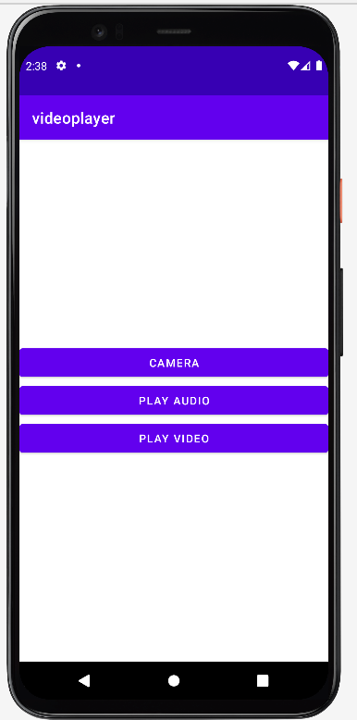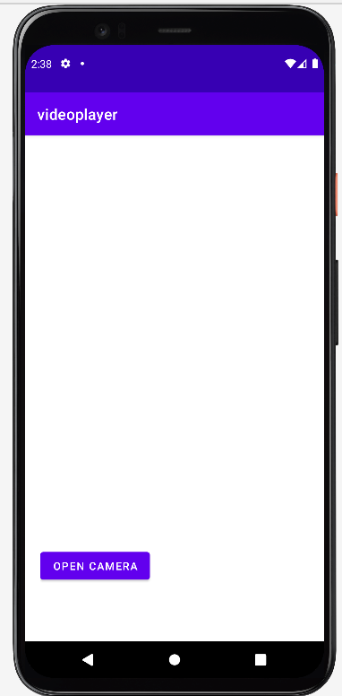 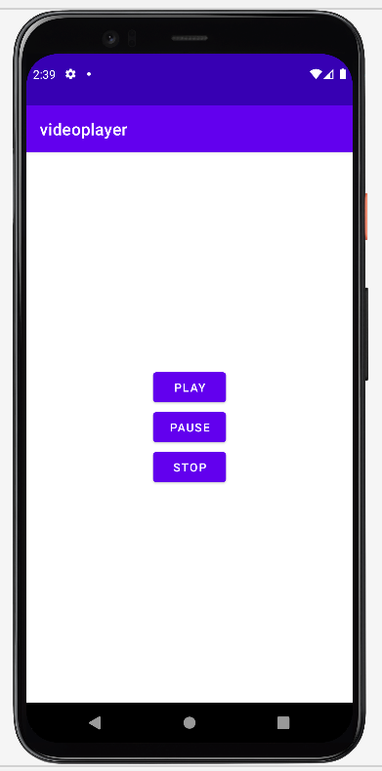

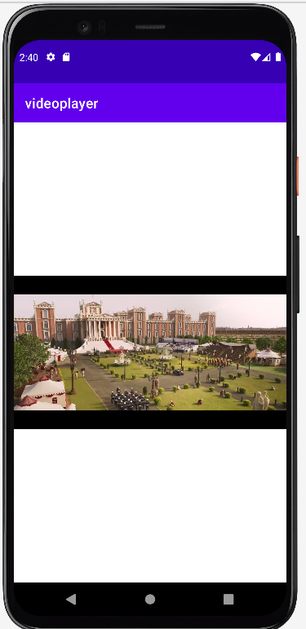

**Result:** The application to implement various android multimedia components is done successfully.